LAB EXPERIMENTS
TOPIC 2
NAME: CH. NAGA ANJALI
REG NO: 192372201
COURSE CODE: CSA0608
COURSE NAME: DESIGN AND ANALYSIS OF ALGORITHM

1.Selection Sort
Question 1: Trophy Ranking System
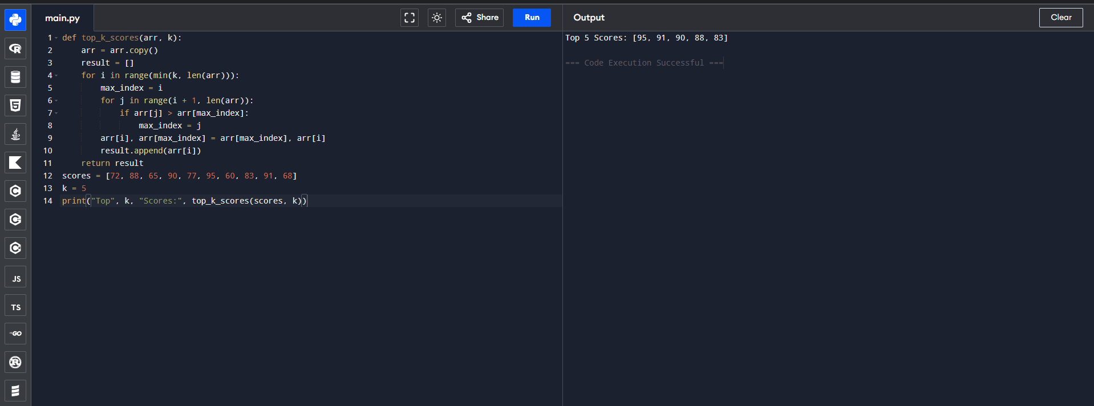
Question 2: Memory-Constrained Embedded Device
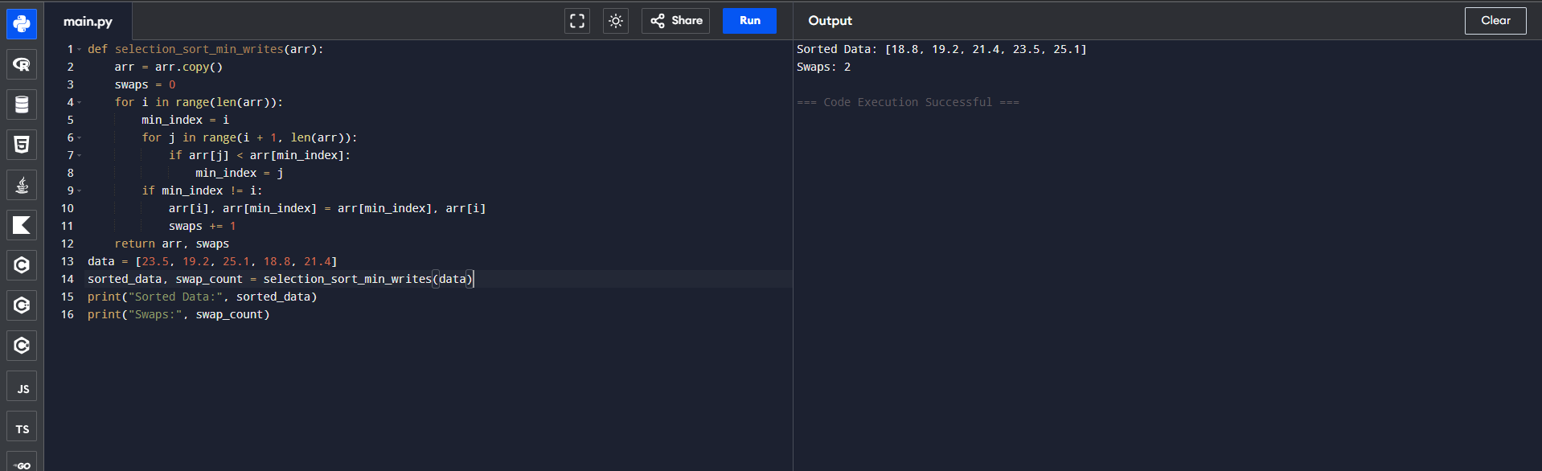
Question 3: Library Book Reordering
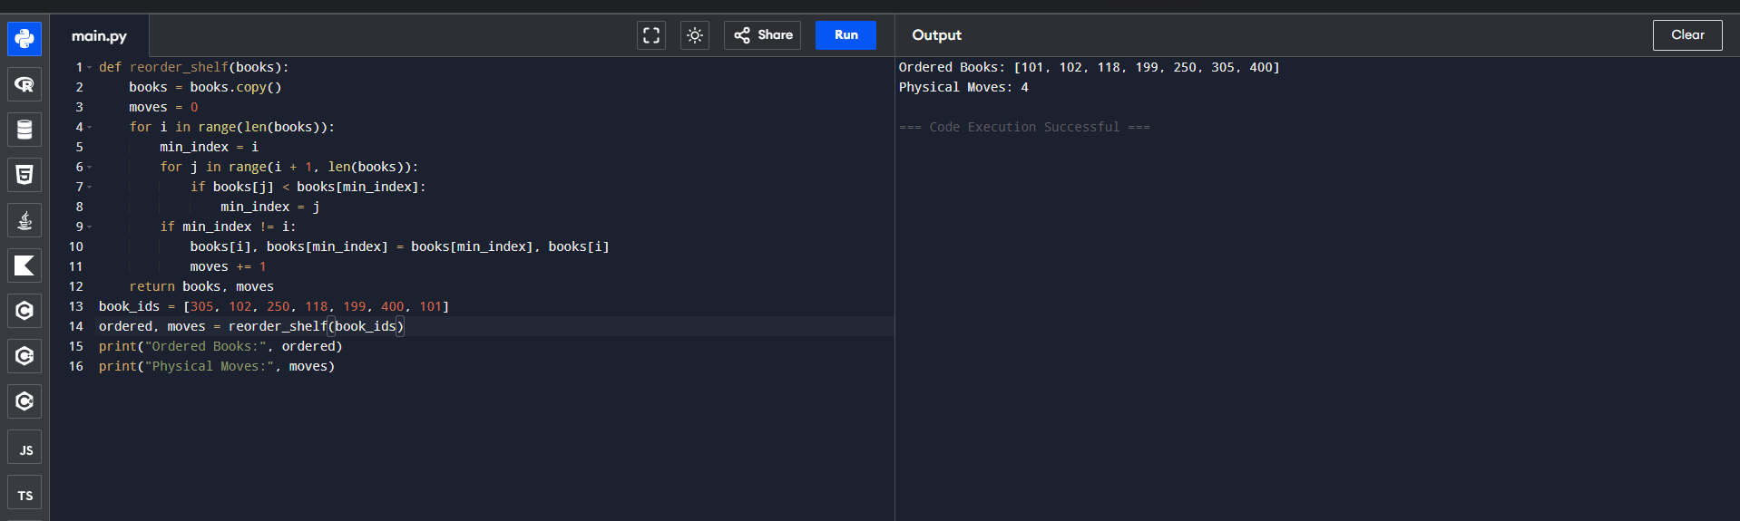
Question 4: Contest Prize Distribution
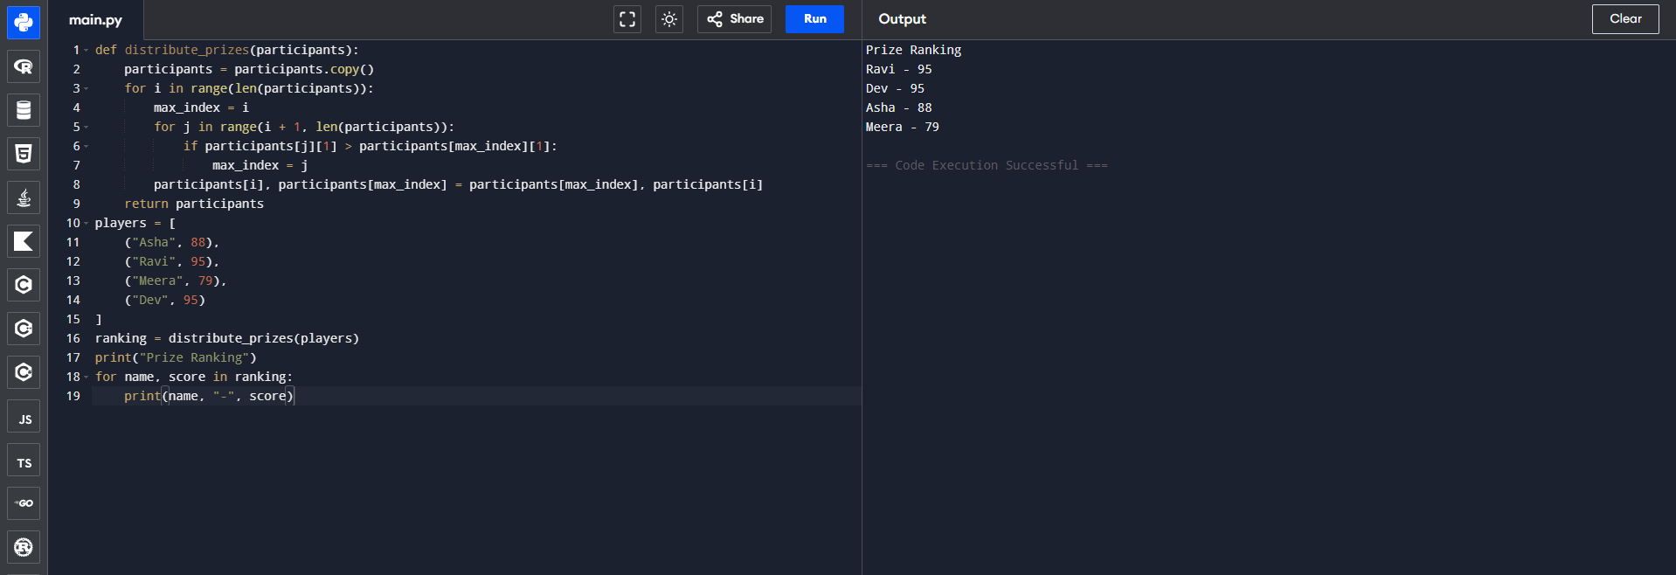
Question 5: Small Dataset in a Mobile App
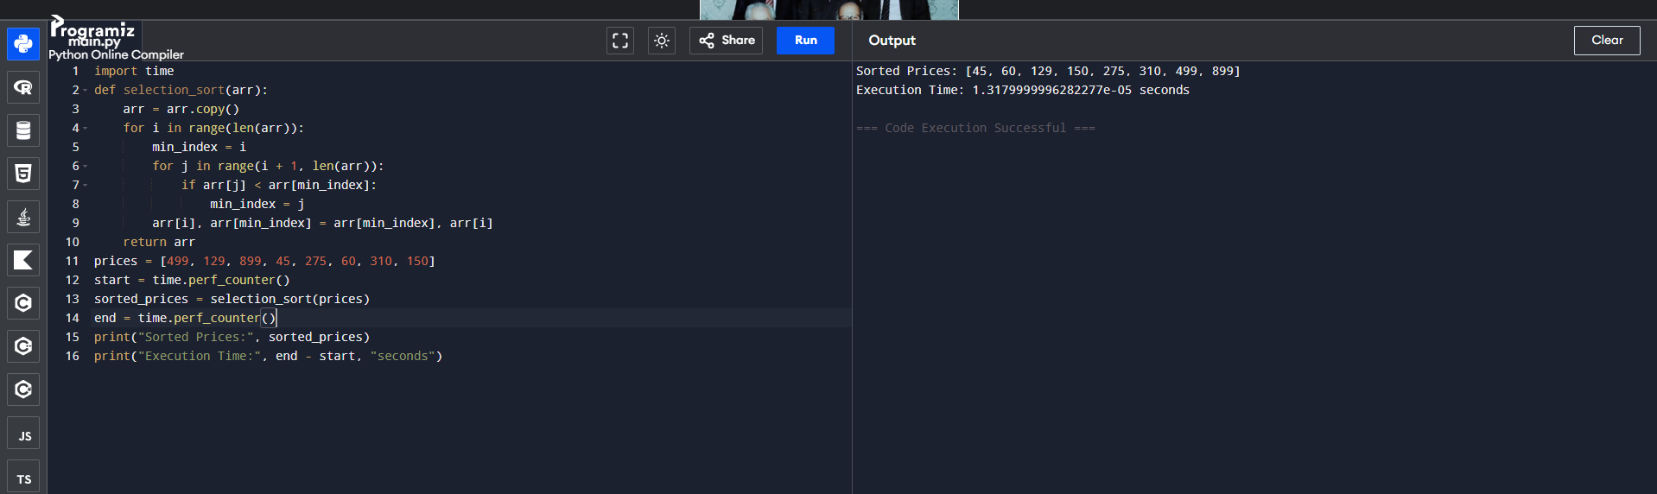
2.BUBBLE SORT
Question 1: Exam Result Slip Correction
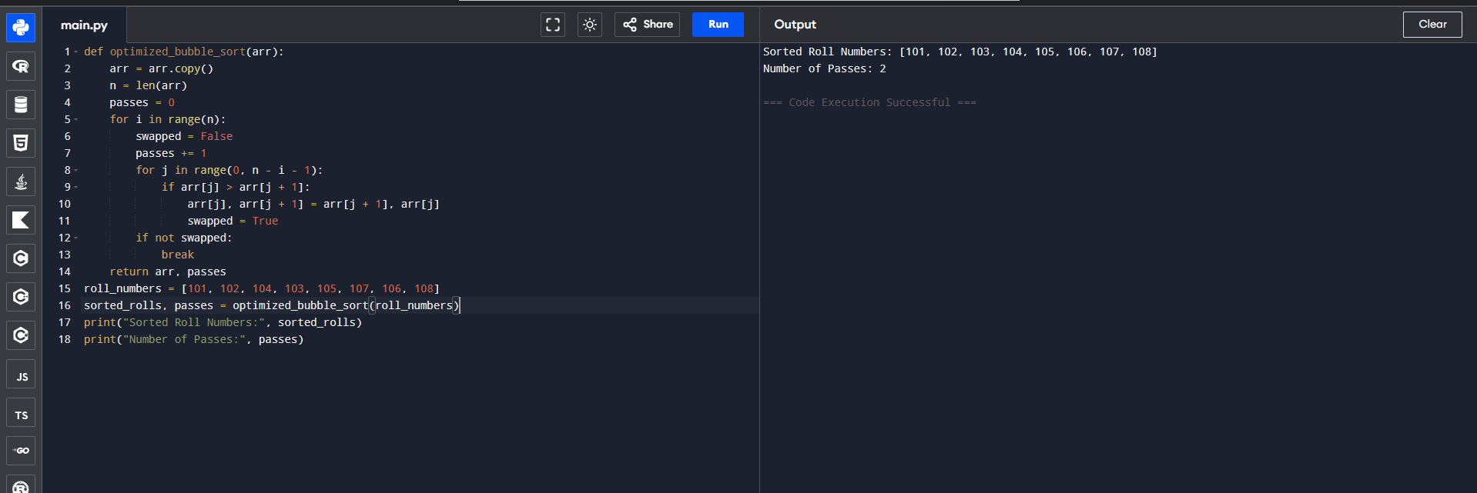
Question 2: Traffic Signal Priority Queue
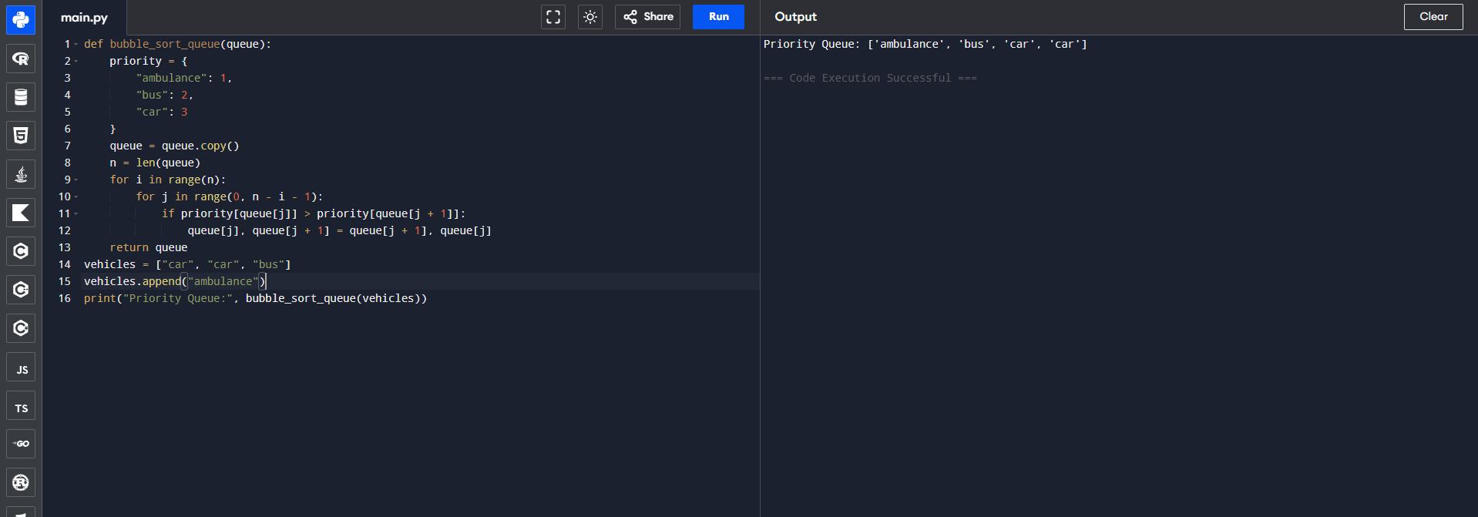
Question 3: Bubble Sort Visualization Tool
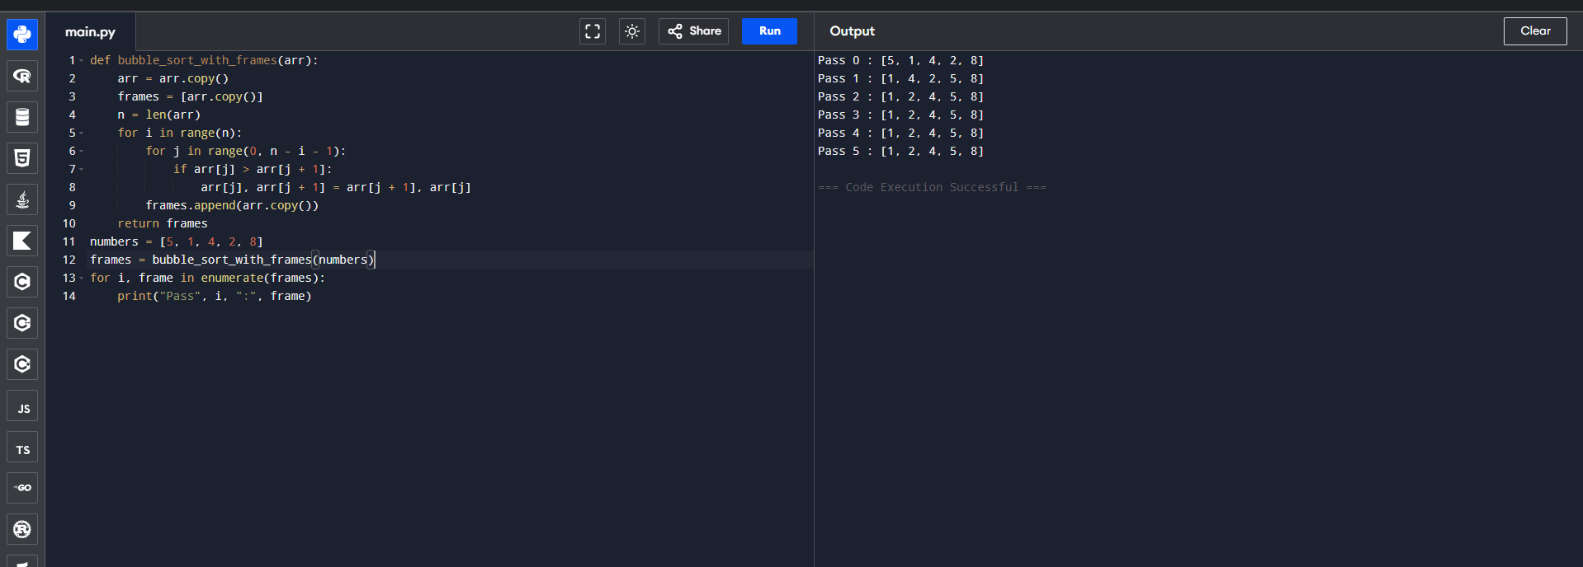
Question 4: Sorting Sensor Alerts by Severity
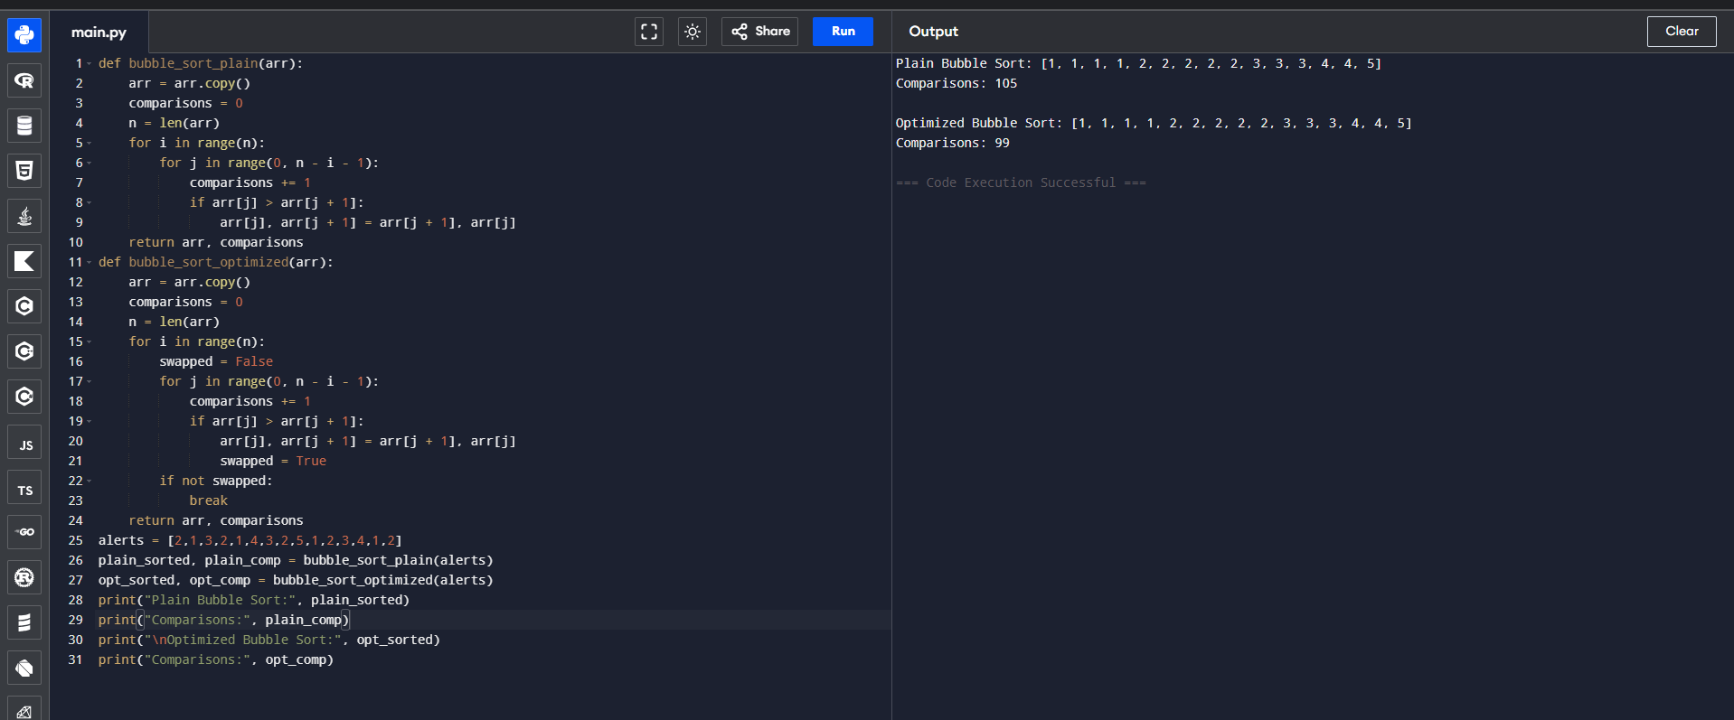
Question 5: Card Game Hand Sorting
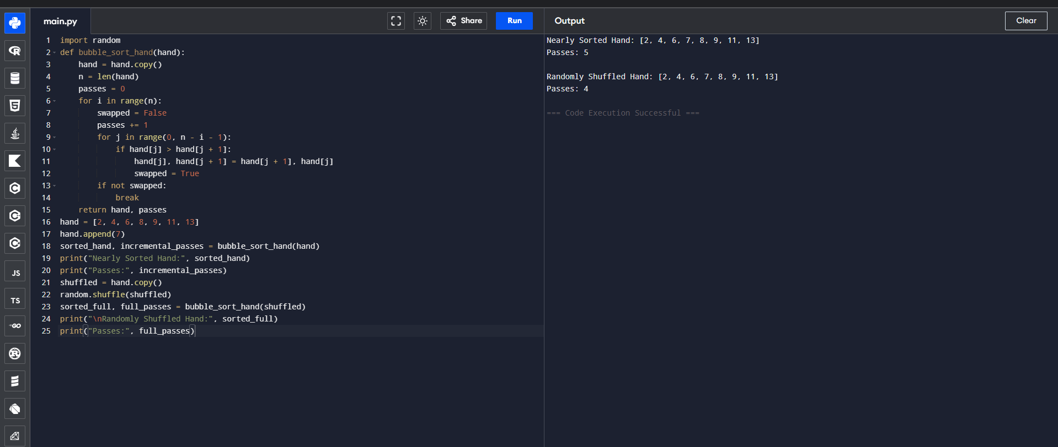
3.Insertion Sort
Question 1: Live Leaderboard Updates
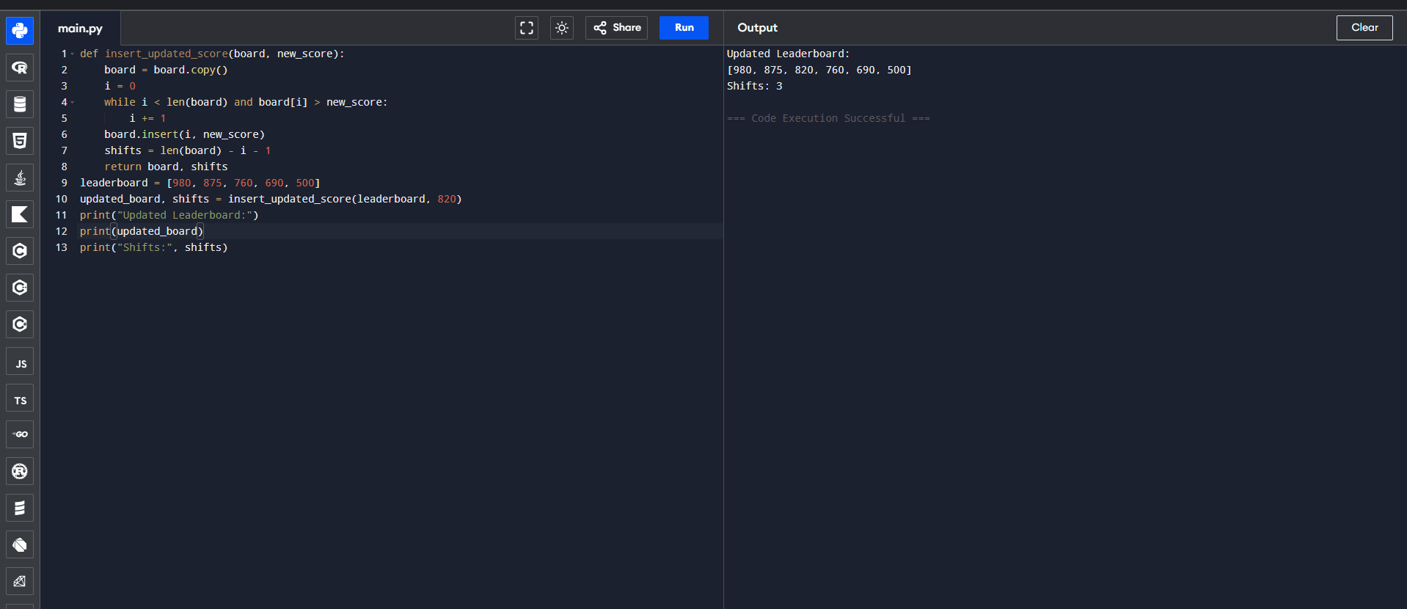
Question 2: Card Sorting While Playing
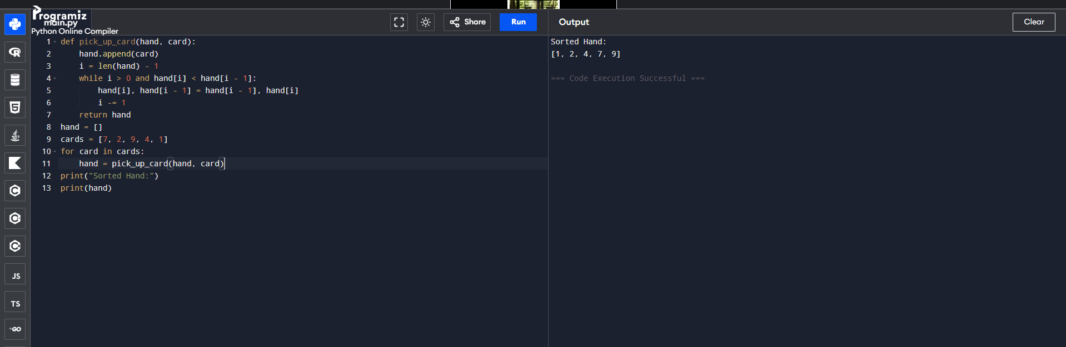
Question 3: Real-Time Stock Price Feed
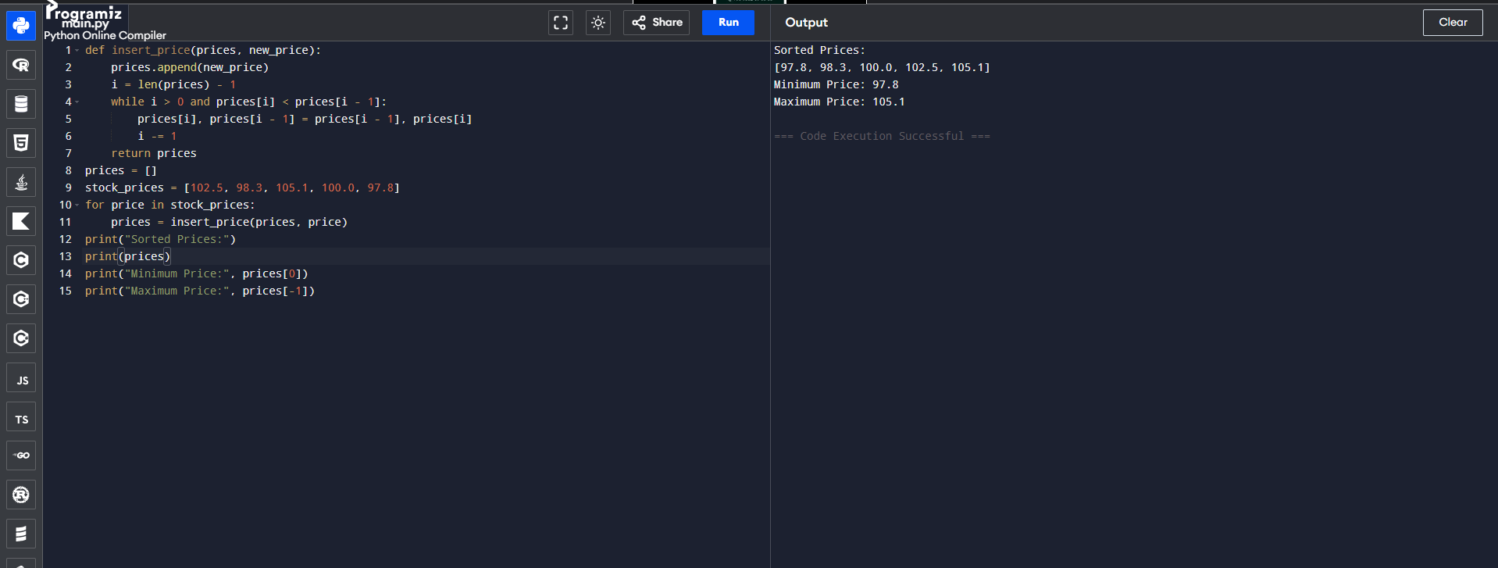
Question 4: Playlist Reordering by Recently Added
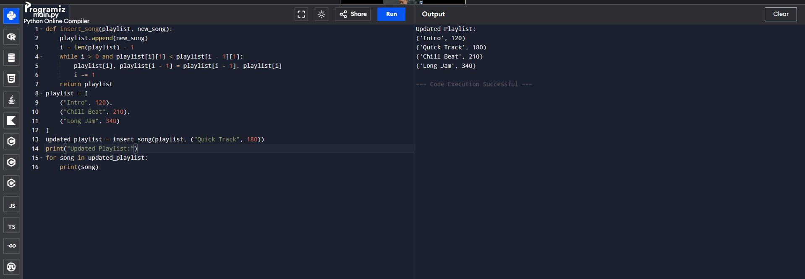
Question 5: Nearly Sorted Sensor Log Correction
